ImplementSVM/Decisiontreeclassificationtechnique

**AIM:**

ToImplementSVMandDecisiontreeclassificationtechniquesusingRprogramming in R Studio.

# SVMINR

#Installandloadthee1071package(ifnotalreadyinstalled) install.packages("e1071") library(e1071)

#Loadtheirisdatasetdata(iris)

#Inspectthefirstfewrowsofthedatasethead(iris)

#Splitthedataintotraining(70%)andtesting(30%)sets set.seed(123)# For reproducibility

sample_indices<-sample(1:nrow(iris),0.7*nrow(iris)) train_data<- iris[sample_indices, ]test_data<- iris[- sample_indices, ]

#FittheSVMmodelsvm_model<-svm(Species~.,data= train_data, kernel = "radial")

#Print thesummary ofthemodelsummary(svm_model)

#Predictthetestsetpredictions<-predict(svm_model, newdata = test_data)

#Evaluatethemodel'sperformance

confusion_matrix<-table(Predicted=predictions,Actual =test_data$Species)print(confusion_matrix)

# Calculate accuracy accuracy<- sum(diag(confusion_matrix))/sum(confusion_matrix) cat("Accuracy:", accuracy * 100, "%\n")

# OUTPUT:

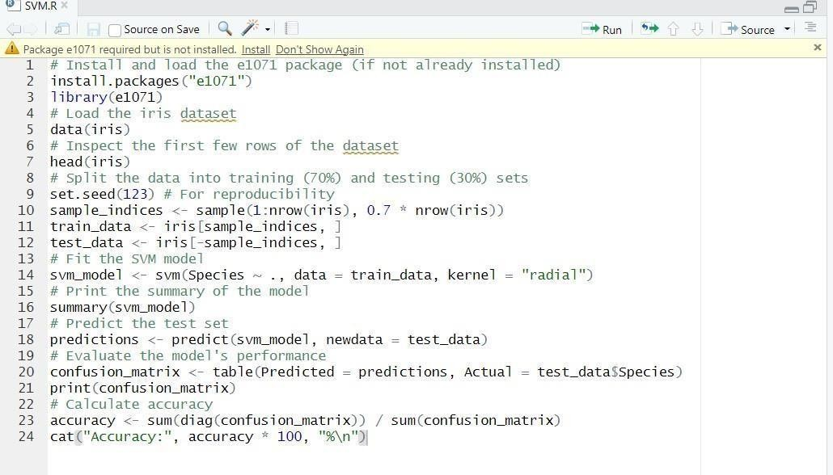

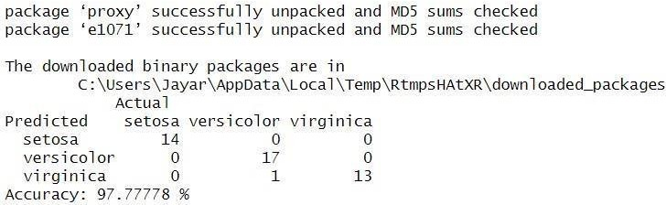

1. **DecisiontreeinR**

#Installandloadtherpartpackage(ifnotalreadyinstalled) install.packages("rpart") library(rpart)

#Loadtheirisdatasetdata(iris)

#Splitthedataintotraining(70%)andtesting(30%)sets set.seed(123)# For reproducibility

sample_indices<-sample(1:nrow(iris),0.7*nrow(iris)) train_data<- iris[sample_indices, ]test_data<- iris[- sample_indices, ]

#FittheDecisionTreemodel tree_model<-rpart(Species~

.,data =train_data, method = "class")

#Printthesummaryofthemodelsummary(tree_model) # Plot the Decision Tree

plot(tree_model)text(tree_model, pretty =

0)

#Predictthetestsetpredictions<-predict(tree_model, newdata = test_data, type = "class")

#Evaluatethemodel'sperformance

confusion_matrix<-table(Predicted=predictions,Actual =test_data$Species)print(confusion_matrix)

#Calculate accuracy

accuracy<-sum(diag(confusion_matrix))/sum(confusion_matrix)cat("Accuracy:", accuracy * 100, "%\n")

# OUTPUT:

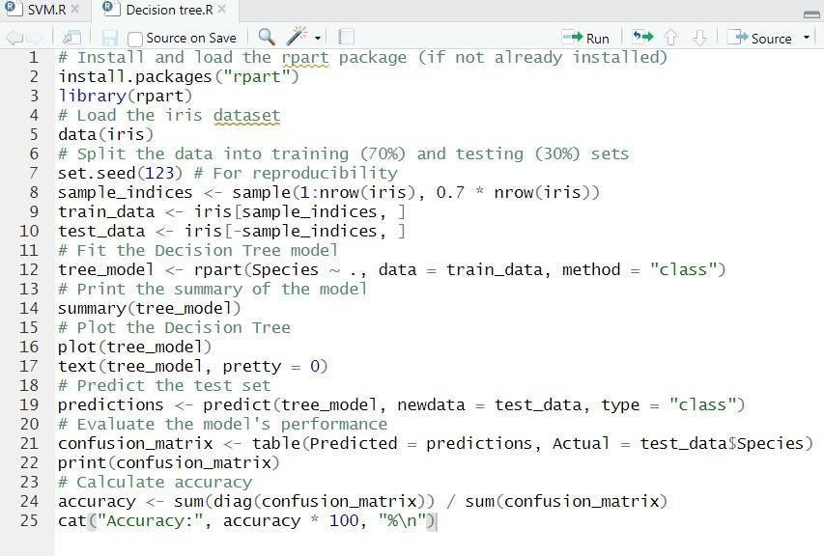

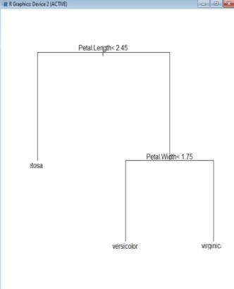

**RESULT:**

Thus,theImplementationSVM/DecisiontreeclassificationtechniquesusingR programming in R Studio.